* **Git in AWS.**

Git is a well-known distributed version control system. There are many other distributed version control systems are present, like Mercurial, Bazar, etc but among them, Git is widely used for some of its unique features.

"Git" refers to using the open-source, distributed version control system called Git with [AWS CodeCommit](https://aws.amazon.com/codecommit/faqs/), Amazon AWS Documentation, Amazon Web Services (AWS) a cloud-based service for storing and managing source code.

* **Installing Git in AWS.**
* **Step 1:** At first, the console of the AWS server should be opened. There the following command should be executed first. This command will help to download & install Git directly at the AWS server. First, it will download the Git & then it will start installing on the server. It will take time.

## *yum install git –y*

## 

**Step 2:**Now it will ask for permission to continue the installation. We have to insert 'y' to start the installation. Wait till the installation is completed.

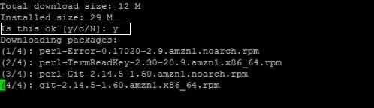

**Step 3:** After installation is completed, the below command should run. This command will prompt the installed version of Git in the AWS server. Hence, the installation is completed.

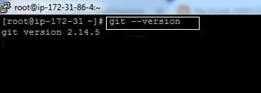

* **Steps to Setup a Git**

**Install Git:** Download and install Git from the official Git website.

**Configure Git:** Set up your username and email.

**git config --**global user.name "Your Name"

**git config --**global user.email "your.email@example.com"

**Create a Repository:** Navigate to your project directory and initialize a Git repository.

**git in:** Make Your First Commit: Add files to the staging area and commit your changes.

git add .

**git commit -**m "Initial commit"

**Basic Git Commands**

**git init:** Initializes a new Git repository.

git init

**git clone [URL]:** Clones a remote repository to your local

machine.

git clone [url]

**git add [file]:** Stages changes to be committed.

git add [file]

**git commit -m "message":** Commits the staged changes with a message.

**git commit -**m "Your commit message"

**git push:** Pushes your commits to a remote repository.

git push origin branch-name

**git pull:** Fetches and merges changes from a remote repository to your local repository git pull origin branch-name

**git status:** Shows the status of changes in your working directory.

git status.